**Name: Sujal Suthar**

**Enrolment No: CSE25**

**Branch: CSEE**

**Class A Batch 12**

**Practical – 13**

Q-1)

Html code:

<html>

<head>

<link rel="stylesheet" type="text/css" href="p13q1.css">

<title>Practical 13.1</title>

</head>

<body id="a">

<h1>Andrew tate</h1>

<p>**Emory Andrew Tate III** (born 1 December 1986) is an American-British media personality, businessman, and former professional [kickboxer](https://en.wikipedia.org/wiki/Kickboxer). He began practising kickboxing in 2005 and gained his first championship in 2009. He attracted wider attention in 2016 when he appeared on the British reality show [*Big Brother*](https://en.wikipedia.org/wiki/Big_Brother_(British_series_17))*.* He was removed from the show after a video emerged of Tate repeatedly striking a woman with a belt; the two later stated the act was consensual. He began operating a [camgirl](https://en.wikipedia.org/wiki/Webcam_model) business and selling online courses, and rose to fame as an [internet celebrity](https://en.wikipedia.org/wiki/Internet_celebrity), promoting an "ultra-masculine, ultra-luxurious lifestyle". Tate's [misogynistic](https://en.wikipedia.org/wiki/Misogynistic) commentary has resulted in his suspension from various social media platforms.</p>

</body>

</html>

Css code: #a{

background-image: url('Andrew_tate.jpg');

background-repeat:no-repeat; background-size:300px 300px;

}

p{ color:blue; padding-left:50px;

}

p:hover{ background-color:red; border:2px dotted black;

}

h1{ color:red;

}

h1:hover{ background-color:blue; border:2px dotted black;

}

Output:

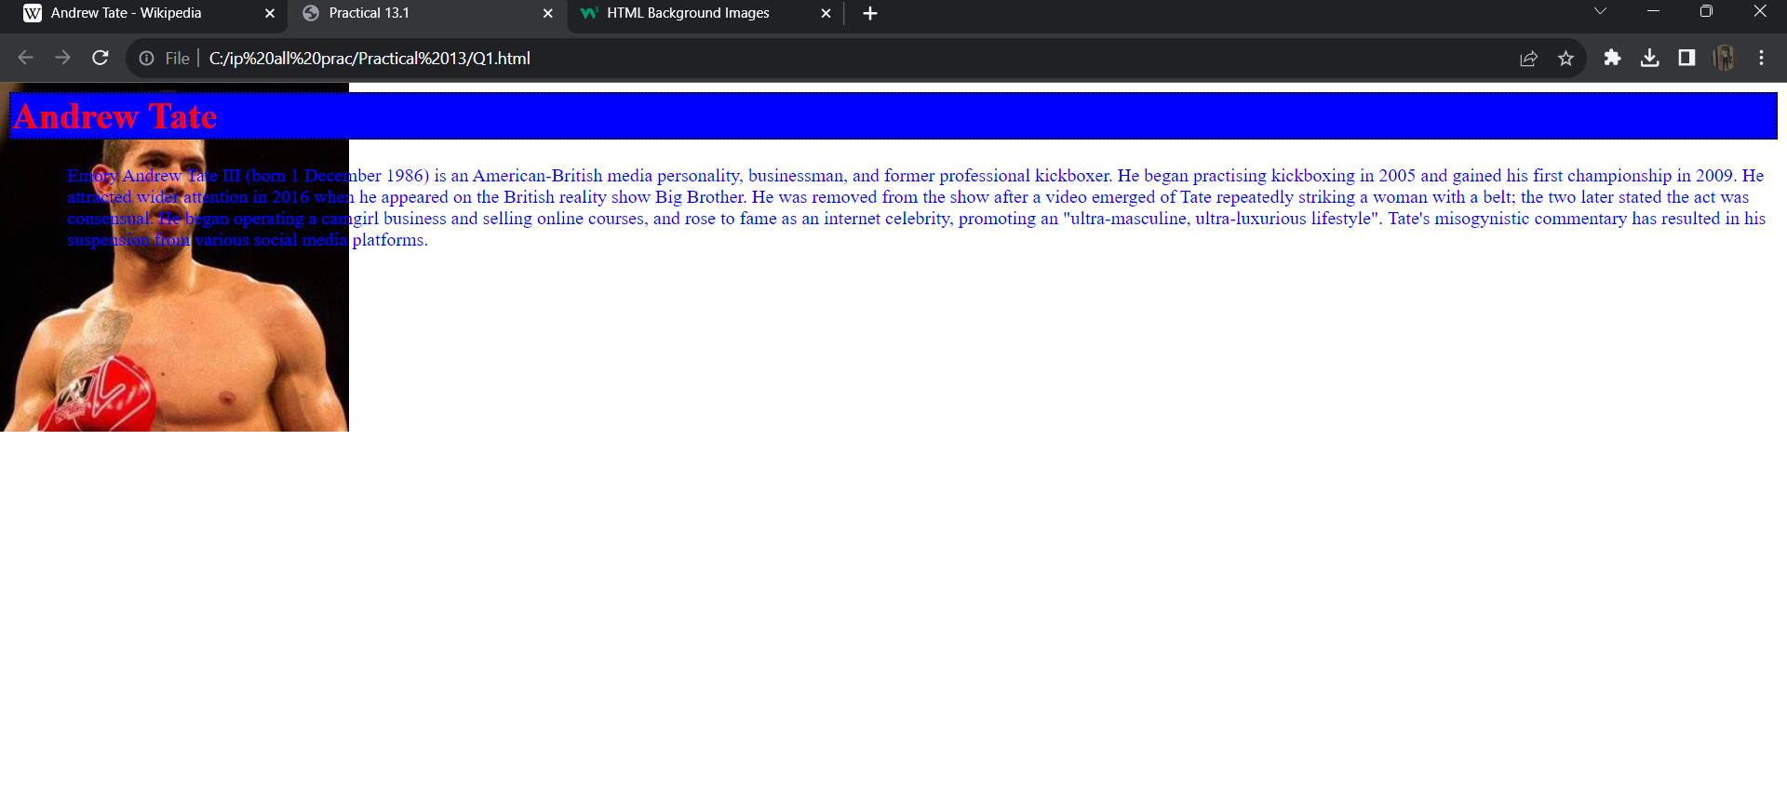

Q-2)

Html code:

<html>

<head>

<link rel="stylesheet" type="text/css" href="p13q2.css">

<title>Practical 13.2</title>

</head>

<body>

<div>

<h2>Father</h2>

<ul>

<li>

<p class="p1"><b>Putting food on the table and a roof overhead</b><br>

Making sure that a child’s basic needs are met is a major expression of love.<br> For some parents throughout the world, it’s also one that is not always easy to accomplish.

</p>

</li>

<li>

<p><b>Making sacrifice</b><br>

Putting a child’s needs before your own sometimes means putting your wants, needs and desires on the back burner – indefinitely.

</p>

</li>

<li>

<p><b>Providing protection from outside dangers</b><br>

Parental responsibility includes always aiming to keep a child safe from harm.

</p>

</li>

</ul>

</div>

<div>

<h2>Mother</h2>

<ul>

<li>

<p class="p1"><b>Always being on call</b><br>

Parents don’t punch a time clock; they are always on duty.<br> Even when a child is grown and living on his or her own, a parent’s job is never done.

</p>

</li>

<li>

<p><b>Teaching life skills</b><br>

One day, your child will leave the nest. A parent’s job in raising a child is to prepare the child for that day.

</p>

</li>

<li>

<p><b>Supporting a child’s interests and dreams</b><br>

In most cases, if something is important to your child, even if you don’t understand why, it is important that your child has your full, unquestioning support.

</p>

</li>

</ul>

</div>

</body>

</html>

Css code:

@font-face

{

font-family:dev;

src:url(RubikGlitch-Regular.ttf);

}

.p1{

background-color:blue;

color:white;

}

p{

color:blue;

}

div:hover{

border-left:10px solid

black; background-color:gray; color:black; opacity:0.5;

}

body{

padding:5px 10px 5px 10px;

}

Output:

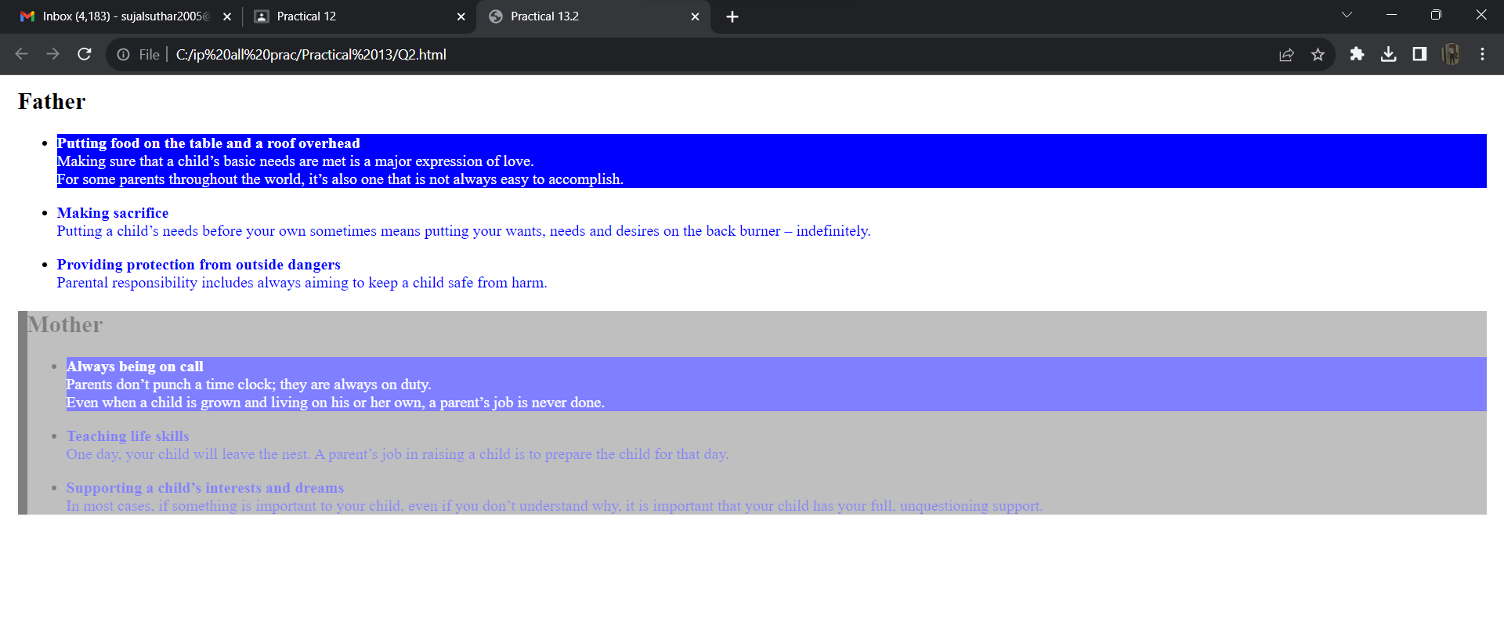

Q-3)

Html code:

<html>

<head>

<title>Practical 13.3</title>

<link rel="stylesheet" type="text/css" href="p13q3.css">

</head>

<body>

<div class="bon">

<ul>

<li><a href="https://www.w3schools.com/default.asp">Home </a>

</li>

<li> <a href="https://www.w3schools.com/default.asp">About us</a> </li>

<li><a href="https://www.w3schools.com/default.asp">Contact us </a> </li>

<li class="dropdown"> <a href="https://www.w3schools.com/default.asp">Addmission</a>

<div class="dropdown-content">

<ul>

<li>CS</li>

<li>BDA</li>

<li>CBA</li>

</ul>

</li>

</ul>

</div>

<br>

<h1 style"z-index:-1;"><center>ICT GANPAT UNIVERSITY</center></h1>

<P>Ganpat University Institute of Computer Technology (ICT) was established in the year 2014.

The institute is approved by the University Grants Commission (UGC) and approved by the

All

India Council for Technical Education (AICTE). ICT offers degree courses in the discipline of Information and Communication Technology, Big Data Analytics, Cyber Security, Cloud Computing and many more.

</P>

<P>It provides specialization in different branches of Computer Science and Engineering field such as Big Data Analysis, Cyber Security & Cloud Based Applications. Also, It is the only

Institute of Gujarat to have collaboration with IBM company and IBM has designed our course plan.

Also, one subject in every semester is taught by the faculty of IBM company.

</P>

</body>

</html> CSS code: body{ background-color:grey;

}

h1:hover{ color:white; background-color:black; border:2px solid green; margin-top:25px;

}

p:hover{ color:white; color:white; background-color:green; border:2px solid black;

}

.bon{ padding-left:500px;

}

.bon ul{ list-style:none;

margin- top:2%;

}

.bon ul li {

background:red; border:2px solid black; width:100px; height:25px; text-align:center;

float:left;

margin:2px;

}

.bon ul li:hover{ backgroundcolor:black; color:white;

}

.bon ul li:hover > ul{ display:block;

}

.bon ul ul ul{ backgroundcolor:gray;

}

.dropdown{

position:relative; display:inline-block;

}

.dropdown-content{

display: none; position: absolute; background-color: #f9f9f9; min-width: 160px; box-shadow: 0px 8px 16px 0px rgba(0,0,0,0.2); padding: 12px 16px; z-index: 1;

}

.dropdown:hover .dropdown-

content { display: block;

}

Output:

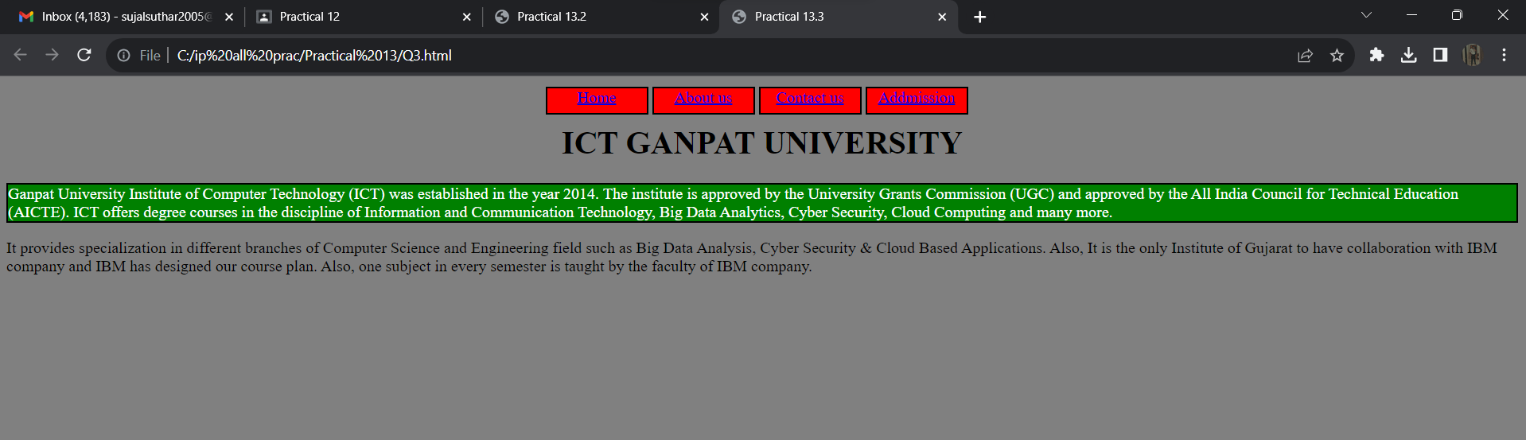

Q-4)

Html code:

<html>

<head>

<title>Practical 13.4</title>

<link rel="stylesheet" type="text/css" href="p13q4.css">

</head>

<body style="background-color:yellow;">

<h1><u><center><strong>Login Form</strong></center></u></h1><br>

<div class="login">

<form>

<label>E-mail: &nbsp&nbsp&nbsp&nbsp</label>

<input type="email" placeholder="someone@xyz.com" required autofocus><br><br>

<label>Password: </label>

<input type="password" pattern="(?=.*\d)(?=.*[A-Z])(?=.*[a-z])(?=.*?[#?!@$%^&*- _\]\[]).{6,8}" placeholder="Enter your Password(6-8 Characters)" title="Must contain at least one number,one uppercase,one lowercase letter and special charcater, and 6 to 8 characters" required><br><br>

<input type="submit" value="Submit">

<input type="reset" value="Reset">

</form> </div>

</body> </html> Css code: input[type=email]{

max-width:300px; padding-

left:20px; border-bottom:1px solid

gray;

}

input[type=password]{

max-width:300px; padding-

left:20px; border-bottom:1px solid

gray; } .login{

background-color:silver;

color:black;

}

input[type=email]:focus{

background-color:gray;

color:white;

border:3px solid red;

}

input[type=password]:focus{

background-color:gray;

color:white;

border:3px solid red;

}

input[type=submit]{

max-width:300px; background-

color:gray; color:white;

}

Output:

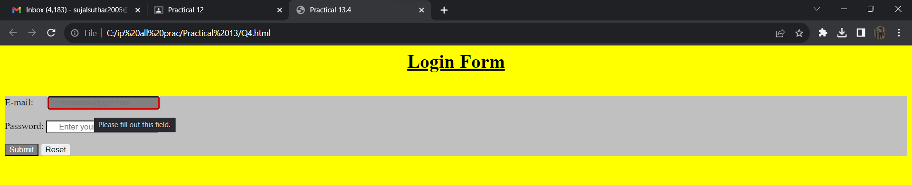

Q-5)

Html code:

<html>

<head>

<title>Practical 13.5</title>

<link rel="stylesheet" type="text/css" href="p13q5.css">

</head>

<body>

<h1><u><strong><center>Registration Form</center></strong></u></h1><br>

<form>

<label>Full Name: &nbsp&nbsp</label>

<input type="text" required autofocus><br><br>

<label>Enrollment Number: &nbsp&nbsp</label>

<input type="text" required><br><br>

<label>Address: &nbsp&nbsp</label>

<input type="text" maxlength="5"><br><br>

<label>Mobile: &nbsp&nbsp</label>

<input type="numbers" required><br><br>

<label>E-mail: </label>

<input type="email" required><br><br>

<label>Gender: </label>

<input type="radio" name="Gender">Male<input type="radio" name="Gender">Female<br><br>

<label>Date of Birth: &nbsp&nbsp</label>

<input type="text" required><br><br>

<input type="submit" formmethod="get" formaction="Q5_1.html" value="Submit1">

<input type="submit" formmethod="post" formnovalidate="formnovalidate" formaction="Q5_2.html" value="Submit2">

</form>

</body> </html> Css code:

input[type=text],input[type=numbers],input[type=email]{

max-width:500px; padding-

left:10px; margin:auto; border-radius:5px;

}

form{

color:white; background-

color:gray; border:2px dotted red;

}

input[type=text]:focus,input[type=numbers]:focus,input[type=email]:focus{

border-bottom:3px solid red; background-color:blue; color:white;

}

input[type=submit]{

max-width:200px; background-

color:green;

margin:auto;

color:white;

text-align:center;

}

Output: 